PHYSICS

YEAR 12

Unit 3

2015

Name: _______________________________________________________

Teacher: ___________________________________________________

TIME ALLOWED FOR THIS PAPER

Reading time before commencing work: Ten minutes
Working time for the paper: Three hours

MATERIALS REQUIRED/RECOMMENDED FOR THIS PAPER

To be provided by the supervisor:
- This Question/Answer Booklet; ATAR Physics Formulae and Data Booklet

To be provided by the candidate:
- Standard items: pens, pencils, eraser or correction fluid, ruler, highlighter.

- Special items: Calculators satisfying the conditions set by the SCSA for this subject.

IMPORTANT NOTE TO CANDIDATES
No other items may be taken into the examination room. It is your responsibility to ensure that you do not have any unauthorised notes or other items of a non-personal nature in the examination room. If you have any unauthorised material with you, hand it to the supervisor before reading any further.

Structure of this paper

Section | Number of questions available | Number of questions to be answered | Suggested working time  (minutes) | Marks available | Percentage of exam
Section One:  Short answer | 10 | 10 | 50 | 54 | 30
Section Two:  Extended answer | 7 | 7 | 90 | 90 | 50
Section Three:  Comprehension  and data analysis | 2 | 2 | 40 | 36 | 20
 |  |  | Total | 180 | 100

Instructions to candidates

- The rules for the conduct of Western Australian external examinations are detailed in the Year 12 Information Handbook 2016. Sitting this examination implies that you agree to abide by these rules.

- Write answers in this Question/Answer Booklet.

- When calculating numerical answers, show your working or reasoning clearly. Give final answers to three significant figures and include appropriate units where applicable.

When estimating numerical answers, show your working or reasoning clearly. Give final answers to a maximum of two significant figures and include appropriate units where applicable.

- You must be careful to confine your responses to the specific questions asked and follow any instructions that are specific to a particular question.

- Spare pages are included at the end of this booklet. They can be used for planning your responses and/or as additional space if required to continue an answer.
  - Planning: If you use the spare pages for planning, indicate this clearly.
  - Continuing an answer: If you need to use the space to continue an answer, indicate in the original answer space where the answer is continued, i.e. give the page number. Refer to the question(s) where you are continuing your work.

Section One: Short response 30% (54 marks)

This section has ten (10) questions. Answer all questions. Write your answers in the space provided.

When calculating numerical answers, show your working or reasoning clearly. Give final answers to three significant figures and include appropriate units where applicable.

When estimating numerical answers, show your working or reasoning clearly. Give final answers to a maximum of two significant figures and include appropriate units where applicable.

Spare pages are included at the end of this booklet. They can be used for planning your responses and/or as additional space if required to continue an answer.

● Planning: If you use the spare pages for planning, indicate this clearly at the top of the page.
● Continuing an answer: If you need to use the space to continue an answer, indicate in the original answer space where the answer is continued, i.e. give the page number. Fill in the number of the question that you are continuing to answer at the top of the page

Suggested working time for this section is 50 minutes.
Question 1
Kepler’s 3rd law of planetary motion is:
$$T^{2}= \frac{{4π}^{2}}{GM} r^{3}$$
Derive this formula using at least two other equations from the supplied data sheet. Show ALL steps in your working. (4 marks)

$F_{g}= \frac{{Gm}_{1}m_{2}}{r^{2}}$ and $F_{C}= \frac{m_{2}v^{2}}{r}$ (1 mark)
$F_{g}= F_{C}$ (1 mark)

$\frac{{Gm}_{1}m_{2}}{r^{2}}$ = $\frac{m_{2}v^{2}}{r}$ (change m₁ to M)

$v= \frac{2πr}{T}$ (1 mark)

$\frac{GM}{r}= \frac{4π^{2}r^{2}}{T^{2}}$ rearrange gives (1 mark)
$T^{2}= \frac{{4π}^{2}}{GM} r^{3}$ (minus one mark if they don’t show this final stage

Question 2
A spherical, 2.00 kg ball, rests on a plane with a slope of 30.0º as shown in the diagram below.

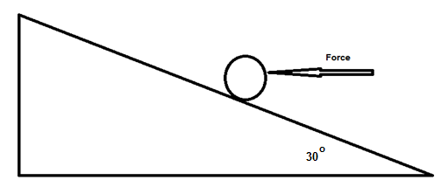
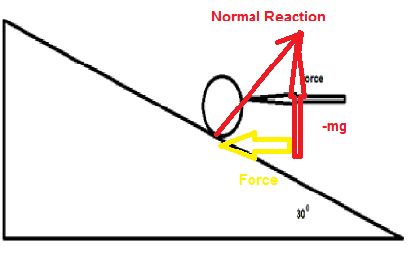
  - Calculate the minimum horizontal force that will prevent the ball moving down the frictionless plane. Include a vector diagram. (3 marks)

mg = 19.6 N (1 mark)

tan 30⁰ = $\frac{Force}{mg}$
= $\frac{Force}{2 x 9.8}$

Force = 11.3 N (1 mark)

Diagram (1 mark)

  - The horizontal force is removed. Calculate the magnitude of the normal reaction force provided by the plane on the ball. Include a vector diagram. (3 marks)
Normal = cos 30⁰ x mg
= 0.8660 x 2 x 9.8 (1 mark)
= 17.0 N (1 mark)

Diagram (1 mark)
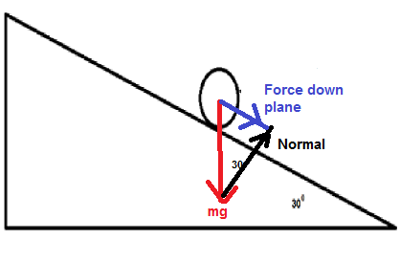

Question 3
A mass spectrometer is used to calculate the mass of charged particles. One such machine is being used to measure the proportion of ${}_{2}^{3}{{He}^{2+} }$ and ${}_{2}^{4}{{He}^{2+} }$ nuclei in a beam of particles that have been accelerated to a speed of 5.11 x 10⁶ m s⁻¹. The magnetic field strength is 5.21 x 10⁻¹ T.
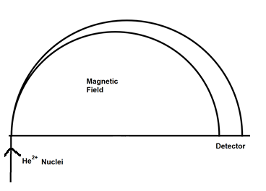
4
Out of the Page
  - Show the direction of the magnetic field on the diagram. (1 mark)

  - Place a “4” on the path followed by the ${}_{2}^{4}{{He}^{2+} }$nucleus. (1 mark)

  - Calculate the mass of the ${}_{2}^{4}{{He}^{2+} }$ given that the radius of its path is 2.01 x 10⁻¹ m.
(3 marks)
$\frac{rBq}{v}= m$ or r_{He-3} < r_{He-4} (1 mark)

m = $\frac{{2.01 x 10}^{-1}{5.21 x 10}^{-1}{3.20 x 10}^{=19}}{{5.11 x 10}^{6}}$ (1 mark)

m = 6.56 x 10⁻²⁷ kg (1 mark)

  - Estimate the radius of the path followed by the ${}_{2}^{3}{{He}^{2+} }$nucleus. (2 marks)

m of He-3 approximately 75% of He-4 (1 mark)

r α m

r = 0.75 x 2.01 x 10⁻¹ m = 1.5 x 10⁻¹ m (1 mark)

Question 4
The volume of a hydrogen atom is 1.99 x 10⁻³¹ m³. Assume the atom is a sphere and the electron travels along its surface.

Volume of a sphere $V=\frac{4}{3}πr^{3}$

Calculate the ________________ force between the proton and the electron for the following:

  - Gravitational. (4 marks)

$v= \frac{4}{3}{πr}^{3}$
1.99 x 10⁻³¹ = $\frac{4}{3}{πr}^{3}$ (1 mark)
r = 3.62 x 10⁻¹¹ m (1 mark)

F = $\frac{G m_{1}m_{2}}{r^{2}}$
= $\frac{{6.67 x 10}^{-11}{1.67 x 10}^{-27}{9.11 x 10}^{-31}}{{{(3.62x 10}^{-11})}^{2}}$ (1 mark)
= 7.74 x 10⁻⁴⁷ N (1 mark)

  - Electromagnetic (2 marks)
$F= \frac{1}{{4πε}_{0}}\frac{q_{1}q_{2}}{r^{2}}$
= $\frac{1}{{4π 8.85 x 10}^{-12}}\frac{{(1.6 {x 10}^{-19})}^{2}}{{{3.62 x 10}^{-11}}^{2}}$ (1 mark)
= 1.76 x 10⁻⁷ N (1 mark)

  - Net force. (1 mark)

F = 1.76 x 10⁻⁷ N (1 mark)

Question 5
Juliette (61.2 kg) decided to build a seesaw using a 4.12 m uniform beam. She was accompanied by her friend, Tyneen (55.1 kg) and her little sister, Georgina (21.6 kg). Draw a diagram showing where the fulcrum could be placed and calculate a location where each person could then sit in order to create equilibrium; given Juliette will sit 1.8 m from the fulcrum (but not necessarily at the edge of the beam) and no person can sit on the fulcrum.
(5 marks)
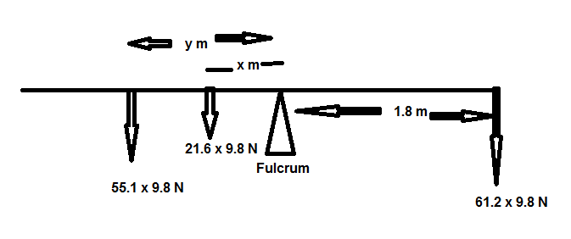
Diagram (1 mark)

Show fulcrum must be centred, else the mass of the beam will not be equal on both sides (1 mark)

ΣM = 0
61.2 × 9.8 × 1.8 = 21.6 × 9.8 × x + 55.1 × 9.8 × y (1 mark)
1079.6 = 211.7 x + 540.0 y

Let x = 2 m, then y = 1.22 m (1 mark giving a value for x or y)
x= | y=
0.25 | 1.90125
0.5 | 1.803241
0.75 | 1.705231
1 | 1.607222
1.25 | 1.509213
1.5 | 1.411204
1.75 | 1.313194
2 | 1.215185
(1 mark finding value for y or x, given the other)

Question 6
An electric beater is used to make bread dough of the right consistency. When the bread dough was too thick, the electric motor jammed and consequently melted. Explain why this happened. (4 marks)
The electric motor in the beater also acts as a generator (1 mark)
thus creating a back emf which reduces emf across the coil in the motor (1 mark).
This means smaller current through the coil (1 mark).
Motor stops spinning back emf stops, emf across coil is much greater, greater current (1 mark) coil fused.

Question 7
  - On the following diagram, draw the magnetic fields. Draw at least ten lines. (4 marks)
1 mk show lines for repulsion (NN) and lines attraction (SN)
1 mk lines enter/exit perpendicular -1 mk lines don’t start on magnets/ball
1 mk lines compressing at steel ball -1 mk lines touch
1 mk lines direction correct

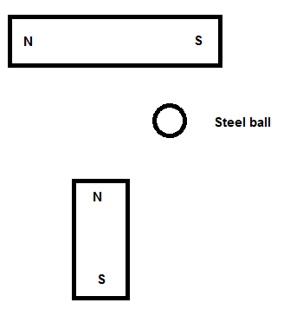

  - Draw the electric fields of the following diagram. Draw at least ten lines. (2 marks)
1 mk lines enter/exit perpendicular
1 mk lines direction correct

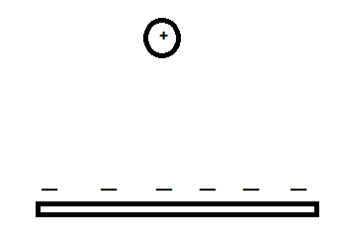

Question 8
A roller coaster with three passengers has a total mass of 9.73 x 10² kg (including the mass of the passengers). The participants experience a force while upside down at the top of the circular track of a “loop the loop” showground ride (that is the rails at the top of the ride exerts a force on the coaster plus passengers). The centre of mass of the roller coaster and passengers is 15.3 m from the bottom of the ride. It is travelling at a constant speed of 12.3 m s^{–1}.
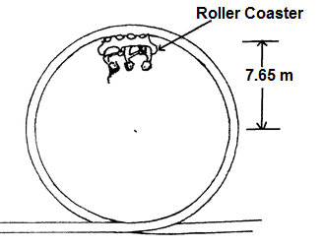
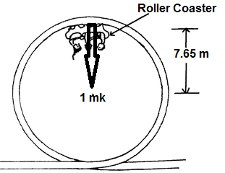
  - On the diagram above, draw a vector to indicate the direction of the force of the rail acting on the coaster plus passengers (Normal Force). (1 mark)

  - Calculate the magnitude of the force that the rails at the top of the ride exerts on the coaster plus passengers (Normal Force). (4 marks)
ΣF = N + W (1 mark)
N(Force of rails on coaster + passengers) = F_{c} – W
= $\frac{{mv}^{2}}{r}$ – mg
= $\frac{{9.73 x 10}^{2}{12.3}^{2}}{7.65}$ – 9.73 x 10² x 9.80
(1 mark) (1 mark)
= 1.92 x 10⁴ – 9.54 x 10³
= 9.71 x 10³ N towards the centre (1 mark)

Question 9
The most common form of regenerative braking in a car involves an electric motor as an electric generator to recharge the car batteries. Explain the process of the battery charging. (4 marks)
An electric car wheels are driven by an electric motor (electricity through a magnetic field produces movement). (1 mark)
When the driver brakes the motor changes into a generator (moving coil in magnetic field produces electricity). (1 mark)
Conservation of energy informs that this electrical energy is converted from the source energy (E_{K}), which slows the car. (1 mark)
This electric current recharges the batteries. (1 mark)

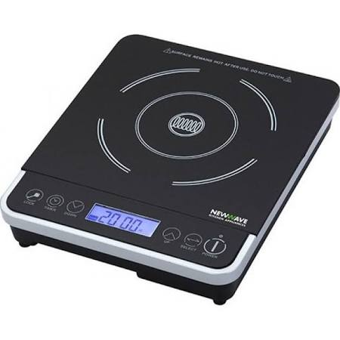
Question 10
The diagram shows a typical hotplate which is commonly used in households, and is also known as an induction heater/hotplate. It can heat water in a saucepan without using a flame.

- Explain how these hotplates can heat water in a saucepan. Include in your answer what material the saucepan should be made of for it to work best. (4 marks)
An induction heater consists of an electromagnet driven by a high frequency AC. (1 mark)
This creates eddy currents in the metal of the saucepan. (1 mark)
These currents, due to resistance, create heat. (1 mark)
Steel or iron (1 mark)
Magnetic hysteresis losses in ferromagnetic materials adds to heating

- Does the hotplate itself get hot during the heating of the water? Explain. (2 marks)
The hotplate will get hot (1 mark)
if remains in contact with the saucepan and water as conduction occurs. (1 mark)

End of Section 1
Section Two: Problem-solving 50% (90 Marks)
This section has seven (7) questions. You must answer all questions. Write your answers in the space provided.
Spare pages are included at the end of this booklet. They can be used for planning your responses and/or as additional space if required to continue an answer.
● Planning: If you use the spare pages for planning, indicate this clearly at the top of the page.
● Continuing an answer: If you need to use the space to continue an answer, indicate in the original answer space where the answer is continued, i.e. give the page number. Fill in the number of the question that you are continuing to answer at the top of the page.
Suggested working time for this section is 90 minutes.
Question 11
Two six-year-old children sit next to each other, at a desk, with their shoulders touching.

  - Estimate the gravitational force between them. (3 marks)
Assumptions: $F= \frac{Gm^{2}}{r^{2}}$
Mass (m) = 20 $±$ 15 kg (1 mark) F = $\frac{{6.67 x 10}^{-11}{20}^{2}}{{0.5}^{2}}$ (1 mark)
r = 0.5 $±$ .3 m (1 mark) F = 1 x 10⁻⁷ N

  - Draw the gravitational field of only one of the children. (Use at least 6 field lines.)
(3 marks)
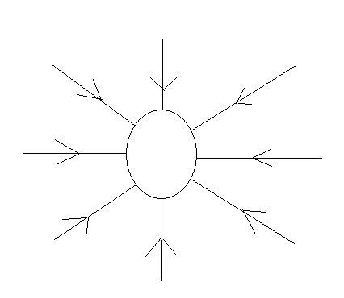
1 mk 6 or more lines start at surface
1 mk lines direction
1 mk no lines touch and centre of mass

  - One of these two children climbs on top of a shelf that is one metre above the ground. Estimate the child’s total mechanical energy when they are standing upright on the shelf. (4 marks)

Assumptions: E_{K} = 0 (1 mark)
Mass (m) = 20 $±$ 5 kg ME = E_{K} + E_{P}
Centre of mass = 0.6 $±$ .2 m (1 mark) = 0 + mgh
= 20 x 9.8 x 1.6 (1 mark)
= 3 x 10² J (1 mark)

  - The child steps off the shelf. When their centre of mass is 0.700 m above the ground estimate their kinetic energy and velocity. (3 marks)
E_{P} = mgh
= 20 x 9.8 x 0.7
= 1.4 x 10² J (1 mark)

E_{K} = $\left(3-1.4\right)$x 10² J
= 2 (1.8) x 10² J (1 mark)

$v= \sqrt{\frac{{2E}_{K}}{m}}$
$v= \sqrt{\frac{{2 x 1.8{x10}^{2}}_{}}{20}}$
v = 4 m s⁻¹ (1 mark)

Question 12
The Perth Wildcats basketball team is two points down and Nat Jawai has the ball in centre court. He puts up the shot and scores three points.
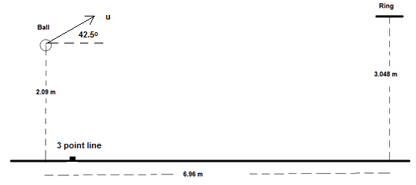
  - In the space below, draw a diagram of the ball showing the force/s acting on it whilst in flight. Assume no air resistance. (2 marks)

Ball

2 marks for just 1 force, 1 mark off for each additional arrow added

  - He propels the ball up at an angle to the horizontal of 42.5º. What is the initial speed of the ball as shown in the diagram? (6 marks)
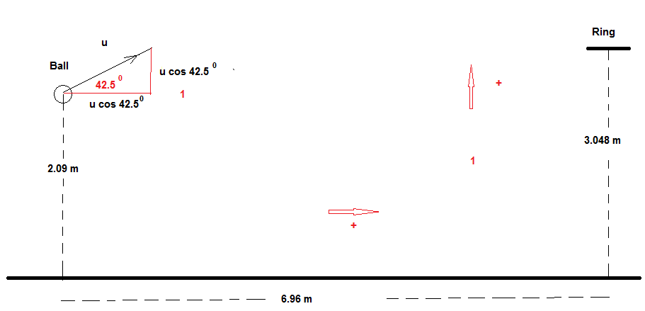
Horizontal Vertical
s_{h} = 6.96 m s_{v} = (3.048 – 2.09) m = 0.958 m
u_{h} = u cos 42.5⁰ m s⁻¹ u_{v} = u sin 42.5⁰ m s⁻¹
a_{h} = 0 a_{v} = -9.80 m s⁻²
t_{h} = T s t_{v} = T s
1 mark for recognising horizontal and vertical parameters
1 mark defining directions

$t= \frac{s_{h}}{u_{h} }= \frac{6.96}{u cos 42.5 }$ (1 mark)

$s_{v}=u_{v}t+ \frac{1}{2} at^{2}$
0.958 = u sin 42.5 x t + $\frac{1}{2} \left(-9.80\right) x t$² (1 mark)
0.958 = u sin 42.5 x $\frac{6.96}{u cos 42.5 }$ + $\frac{1}{2} \left(-9.80\right) x (\frac{6.96}{u cos 42.5 })$² (1 mark subbing in t)
0.958 = tan 42.5 x 6.96 + $\frac{1}{2} \left(-9.80\right) x (\frac{6.96}{u cos 42.5 })$²
0.958 = 6.38 - $\frac{437}{u^{2}}$
u² = 437/(6.38-0.958) = 80.6
u = 8.98 m s⁻¹ (1 mark)

  - Calculate the velocity as it passes through the ring in order to score the three points to win the game. (If unable to get a result for part (b), use 9.1 m s⁻¹). (6 marks)
u_{h} = u cos 42.5 u_{v} = u sin 42.5
= 6.61 m s⁻¹ = 6.06 m s⁻¹ (1 mark)
v_{h} = 6.61 m s⁻¹ (1 mark) v_{v}² = u² + 2as
v_{v}² = 6.06² + 2 (-9.8) 0.958
v_{v}²= 18.0
v_{v} = $±$4.24 m s⁻¹ (1 mark)

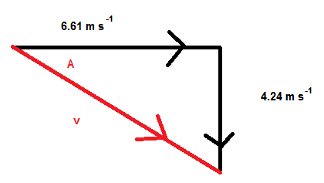
v² = 6.61² + 4.24² (1 mark or diagram)
v = 7.86 m s⁻¹ (1 mark)

tan A = $\frac{4.24}{6.61}$
A = 32.7⁰ (1 mark)

  - On the diagram below, draw the path of the ball with and without air resistance. Assume that the basketball is launched with the same initial velocity. (2 marks)

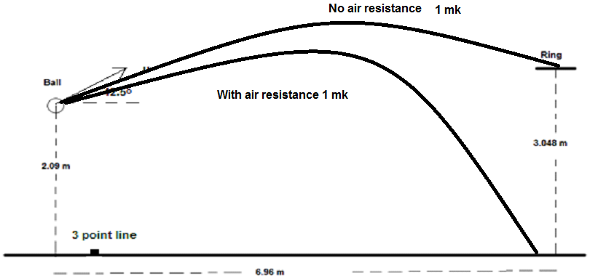

Question 13
At the centre of the Milky Way is a black hole known as Sagittarius A*. It has a mass equivalent to 4.31 billion Suns. It is 26 500 light years from the Sun. A light year is the distance light would travel in one year.
  - Calculate the gravitational force between the black hole and the Sun. (3 marks)
$F= \frac{{Gm}_{1}m_{2}}{r^{2}}$
r = $26500 x 365.25 x 24 x 3600 x {3 x 10}^{8}$ = 2.5008 x 10²⁰ (1 mark)
$F= \frac{{{6.67 x 10}^{-11}{1.99 x 10}^{30}{4.31 x 10}^{9}{1.99 x 10}^{30}}_{}}{{{(26500 x 365.25 x 24 x 3600 x {3 x 10}^{8})}^{2}}^{}}$ (1 mark)
F = 1.81 x 10¹⁹ N (1 mark)

  - Using this force (from part a), to calculate the orbital speed of the Sun around the black hole. (If no value was obtained in part (a), use. F = 2.00 x 10¹⁹ N and r = 2.45 x 10²⁰ m) (2 marks)
$F= \frac{m_{2}v^{2}}{r}$
1.81 x 10¹⁹ = $\frac{{1.99 x 10}^{30}v^{2}}{{26500 x 365.25 x 24 x 3600 x 3 x 10}^{8}}$ (1 mark)
v = 4.78 x 10⁴ m s⁻¹ (1 mark)

  - The Sun moves around the black hole (assume in a circular orbit) with a speed of 2.20 x 10² km s⁻¹. Calculate the centripetal force involved in creating this orbit. (2 marks)
2.20 x 10² km s⁻¹ is 2.20 x 10⁵ m s⁻¹
$F= \frac{m_{2}v^{2}}{r}$
$F= \frac{{1.99 x 10}^{30}{{2.20 x 10}^{5}}^{2}}{{26500 x 365.25 x 24 x 3600 x 3 x 10}^{8}}$ (1 mark)
F = 3.84 x 10²⁰ N (1 mark)

  - Compare the force values of part a) and c). Explain why they are different. (3 marks)
The second force is ~20x greater than the first, possibly because: (1 mark)
- Mass from rest of Milky Way contributes to force
- Dark matter
- Error in estimates (mass of Sagittarius A*)
- Error in estimates (distance between objects)
(2 marks for any two or other possibilities)
Or similar

Question 14
A yacht is moored in a marina being prepared for the Sydney to Hobart race. The uniform boom is 1.50 m above the deck and the uniform cable is attached 1.20 m from the end of the boom (mass 61.5 kg). A 50.0 kg weight is attached at the free end of the boom to prevent sudden movement.

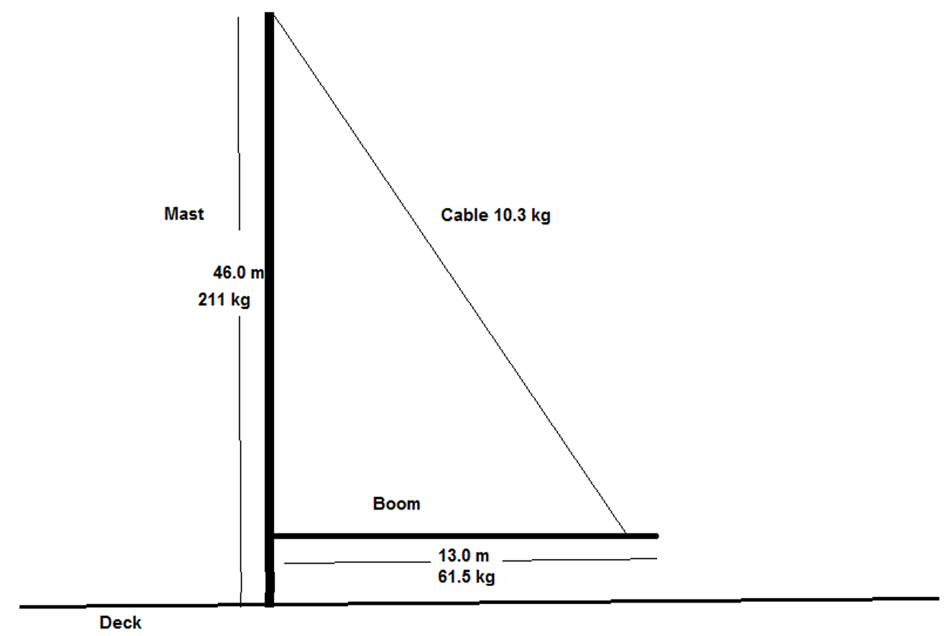
  - Draw a free body diagram of the boom, in the space below, showing all forces acting on it and then show the resultant force of the mast on the boom. (4 marks)
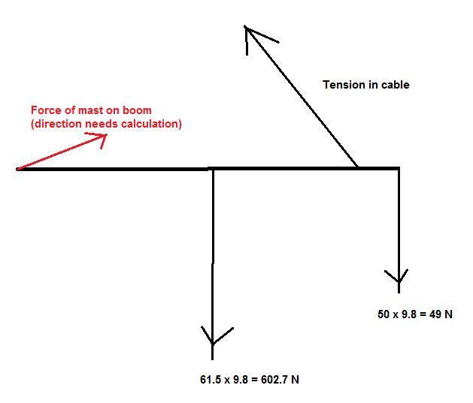
1 mark for each force correct

  - Calculate the tension in the cable remembering the cable itself has a mass of 10.3 kg.
(5 marks)
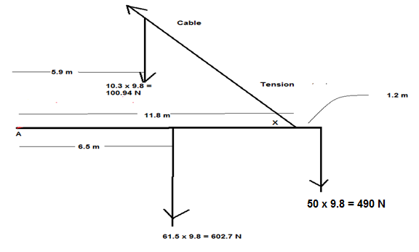
Calculate X: tan X = $\frac{44.5}{11.8}$ (1 mark)
X = 75.1⁰ (1 mark)

Take moments about A (CW +) (1 mark vector CW +)
0 = 490 x 13 + 602.7 x 6.5 + 100.94 x 5.9 – T sin 75.1⁰ 11.8 (1 mark)
T = 954 N (1 mark)

  - Calculate the force exerted by the mast on the boom. (5 marks)
Vertical Forces (down +)
F_{V} = 100.94 + 602.7 + 490 – 954 sin 75.1⁰
= 271 N (1 mark)

Horizontal Forces (left +)
F_{H} = 954 cos 75.1⁰
= 245 N (1 mark)
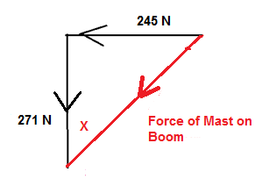
(1 mark for diagram showing angle or description of where angle is taken from)
Force of mast on boom = (245² + 271²)^{0.5} = 365 N (1 mark)
X = tan⁻¹ $\frac{245}{271}$
= 42.1⁰ (1 mark)

  - What benefit is there if the cable attachment to the boom is shorter, i.e. the boom is supported at a location less than 11 m? (1 mark)
Shorter length smaller tension in the cable. (1 mark)

Question 15
AC and DC generators are important technological devices.
  - Using labelled diagram/s illustrate and explain how an AC generator creates an AC voltage. (5 marks)
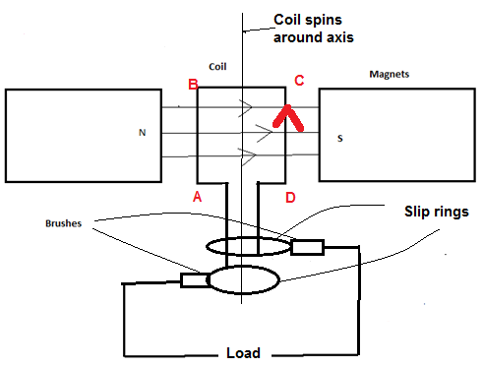
(1 mark coil and magnet, 1 mark slip rings)
Coil is spun in magnetic field, produces emf (1 mark)
If spins CW (CD out of page) current always up right hand side, in current orientation current enters via top slip ring (1 mark)
When AB on right current enters through bottom slip ring (1 mark)
Hence current changes direction (AC)

  - At which stage of the cycle is a maximum emf generated? Explain what factors influence the amount of emf. (4 marks)
When coil is parallel with field OR when no flux is contained in area of coil. (1 mark)
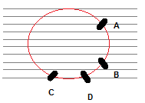(1 mark)
Size of emf is determined rate of change of flux (1 mark)
It takes approximately the same time for coil to travel AB as CD, change in flux much greater AB (1 mark)

Or similar

  - Explain the difference in design necessary to change the AC generator to a DC generator. Use diagrams. (5 marks)
Change the slip rings to split ring commutators (1 mark)
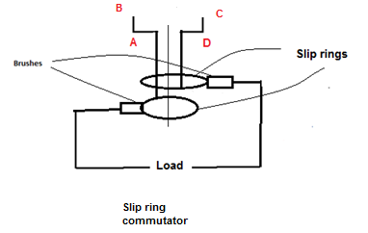 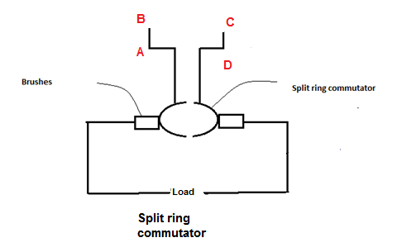(2 marks)
Brush always connected to one side Split ring connected to CD is in contact
eg top slip ring/brush always with right half but quarter turn from
connected to CD (1 mark) current position will be making contact
with left brush (1 mark)
AC DC

Or similar

  - The equation
$${emf}_{rms}= \frac{{emf}_{max}}{\sqrt{2}}$$
is used to calculate the maximum emf created in an AC generator. Explain, using an appropriate voltage vs time graph for Australia’s current electricity standards, what is the importance of $\sqrt{2 }$in this equation. (3 marks)
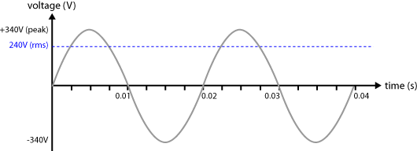 (2 marks)
Need to show correct proportions. Can be other voltages.
Need a label for peak and rms (don’t need values provide correct proportions)

$\sqrt{2 }$ is the factor that is equal to the value of the direct voltage that would produce the same power dissipation across a resistor. (1 mark)

Or similar

Question 16
Two parallel charged plates are set up as in the diagram below.
  - Draw the electric field between the plates. (3 marks)
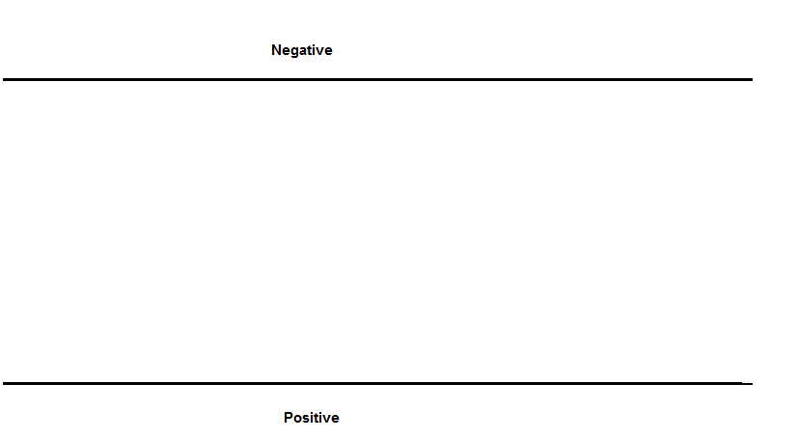
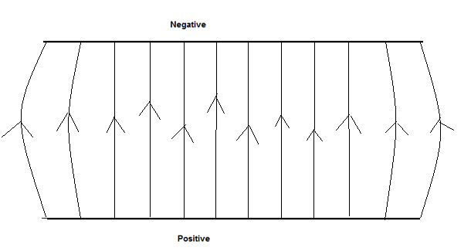

1 mark for field up
1 mark for equal distance between lines
1 mark for bowed ends or perpendicular

  - A proton is fired, with a velocity of 8.67 x 10⁷ m s⁻¹, into the space between the 0.500 m long plates as shown below. The plates are 20.0 mm apart and the potential difference between the plates is 3.00 x 10³ V.

The experiment is placed vertically to the ground and the proton is effected by gravity.

Calculate the total force acting on the proton as it travels between the plates.
(4 marks)
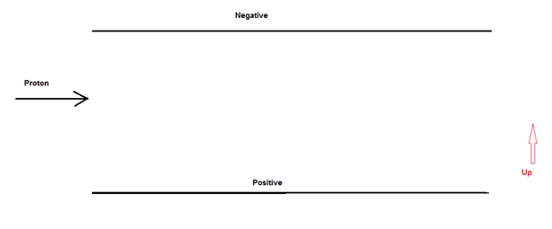
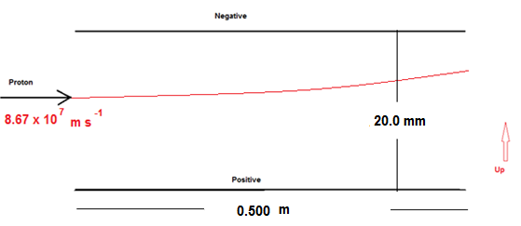 (1 mark)
Gravitational = mg = 1.67 x 10⁻²⁷ x 9.80 N = 1.64 x10⁻²⁶ N down (1 mark)

Electric Field force = $\frac{Vq}{d}$ = $\frac{3000 x {1.6 x 10}^{-19}}{0.020}$ = 2.4 x 10⁻¹⁴ N up (1 mark)

Total force up = 2.40 x 10⁻¹⁴ N up as gravity is insignificant (1 mark)

  - Calculate the velocity at which the proton leaves the gap between the plates.
(5 marks)
a = $\frac{F}{m}$ = $\frac{{2.4 x 10}^{-14}}{{1.67 x 10}^{-27}}$ = 1.44 x 10¹³ m s⁻²

Vertical
t = $\frac{s}{v}= \frac{.5}{{8.67 x 10}^{7}}$
= 5.77 x 10⁻⁹ s
v = u + at
= 0 + 1.44 x 10¹³ x 5.77 x 10⁻⁹
= 8.31 x 10⁴ m s⁻¹ (1 mark)

Horizontal
v = 8.67 x 10⁷ m s⁻¹ (1 mark)
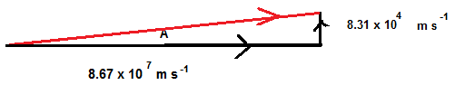
(1 mark)
Final velocity = [(8.67 x10⁷)² +(8.31 x10⁴)²]^{0.5}
= 8.67 x 10⁷ m s⁻¹ (1 mark)
sin⁻¹ A = $\frac{8.31 x {10}^{4}}{{8.67 x 10}^{7}}$
A = 0.0549º (1 mark)

  - Calculate the vertical displacement of the proton whilst it is between the plates.
(2 marks)
$t=$5.77 x 10⁻⁹ s (1 mark)
$s= v_{av}t= \frac{{8.31 x 10}^{4}}{2} x {5.77 x 10}^{-9}=2.39$x 10⁻⁴ m (1 mark)

Question 17
A truck is being driven around a roundabout, of radius 75.0 m, and it rolls over.
  - Explain, using a diagram and referring to centre of mass, why the truck would roll over. (2 marks)
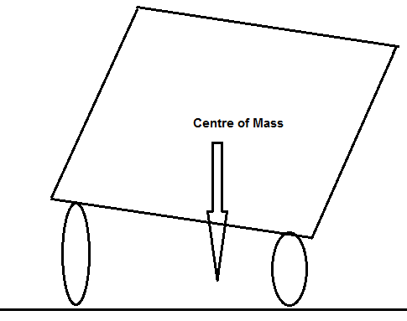 (1 mark)
If truck leans over so that the vertical line from CoM to the ground is outside of wheelbase it will roll over (1 mark)

  - Road engineers bank roads to help prevent such situations occurring. What angle must the road in part (a) be banked to allow the driver to travel through the roundabout, safely, at 10.0 m s⁻¹. At the safe speed the truck corners without relying on friction between the wheels and the road. Include a vector diagram. (3 marks)
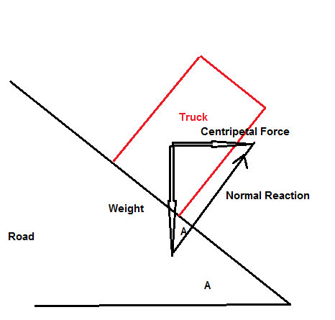 (1 mark)
tan A = $\frac{Centripetal Force}{Weight}= \frac{{mv}^{2}}{mgr}= \frac{v^{2}}{gr}= \frac{{10}^{2}}{9.8 x 75}$ (1 mark)
A = 7.75º (1 mark)

End of Section 2
Section Three: Comprehension and Data Analysis 20% (36 Marks)
This section contains two (2) questions. You must answer both questions. Write your answers in the space provided.
Spare pages are included at the end of this booklet. They can be used for planning your responses and/or as additional space if required to continue an answer.
● Planning: If you use the spare pages for planning, indicate this clearly at the top of the page.
● Continuing an answer: If you need to use the space to continue an answer, indicate in the original answer space where the answer is continued, i.e. give the page number. Fill in the number of the question that you are continuing to answer at the top of the page.
Suggested working time for this section is 40 minutes.

Question18 Circular Motion (18 marks)
Many everyday examples rely on circular motion. Satellites for weather observations, GPS, communications and monitoring activities is one such group. Some others include spin dryers in washing machines, separating blood samples into its components in a centrifuge and mass spectrometers.

Centrifugal force does not exist in an inertial frame of reference and is generally considered to be a “mythical” or inertial force. In the past, it was sometimes defined as the reaction force to the centripetal force. Centrifugal is based on the Latin word which means flight (moving away from centre), centripetal comes from the Latin for seeking (moving towards centre).

A satellite orbiting the Earth in a circular orbit is always falling towards the Earth yet maintains the same altitude.

Rockets are used to place satellites in their respective orbits. Satellites that have orbits parallel to Earth’s equator are generally launched in an easterly direction from the east coast close to the equator.

Geostationary satellites are usually launched in this manner. These satellites are a significant reason that we can receive continuous TV signals from the other side of the world. Pay TV companies also use geosynchronous satellites as well as cable to provide services to their customers. They are also valuable in weather services as each satellite monitors a set part of the Earth’s surface.

An experiment to demonstrate the forces involved in circular motion is set up as follows:
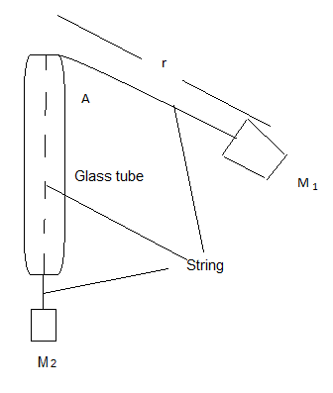
A student holds the glass tube and swings the rubber stopper (M₁) in a circle maintaining a constant radius. The force (tension in the string) is provided by the mass (M₂). Another student measures the time taken for 25 revolutions.

The following is a set of results for one such experiment.

M₁ has a mass of 38.3 g
r is 61.3 cm
Trial | Force of M₂  (N) | Time for twenty (25) revolutions  (s) | Period  (s) | Velocity²  (m² s⁻²)
1 | 0.50 | 34.1 | 1.36 | 8.0
2 | 1.50 | 19.7 | 0.79 | 23
3 | 2.50 | 15.3 | 0.61 | 40
4 | 3.50 | 12.9 | 0.52 | 56
5 | 4.50 | 11.4 | 0.46 | 71
6 | 5.50 | 10.3 | 0.41 | 87

Period = 34.1/25
v² = (2 π r /T)²

Trial | Force of M₂  (N) | Time for twenty (25) revolutions  (s) | Period  (s) | Velocity²  (m² s⁻²)
1 | 0.50 | 34.1 | 1.36 | 8.0
2 | 1.50 | 19.7
3 | 2.50 | 15.3
4 | 3.50 | 12.9
5 | 4.50 | 11.4
6 | 5.50 | 10.3

  - Complete the two incomplete columns. Assume the string is swung horizontally.
(1 mark)

  - Which is the independent variable? (1 mark)
Force (N) (1 mark)
  - Plot the data of the Force versus Velocity squared. (3 marks)

TITLE: Force and velocity² graph
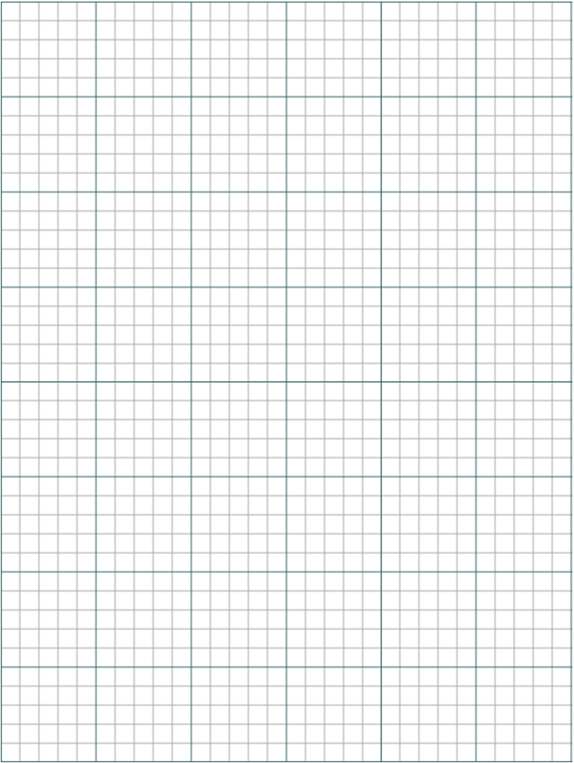
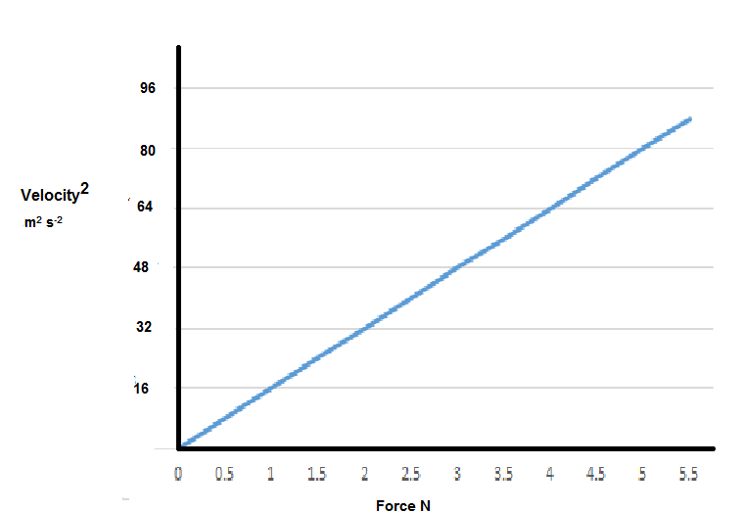
1 mark plots,
1 mark scale,
1 mark units

  - Plot a line of best fit. (1 mark)

  - Find the gradient of F α V². (2 marks)
Gradient = $\frac{Rise}{Run}$
= $\frac{5.5}{87}$
= 0.0625 N s² m⁻²
= [0.0625 kg m⁻¹]
1 mark magnitude, 1 mark units

  - What is the important information of the gradient? (1 mark)
Ratio of length of string to mass of M₁ = 0.613/0.0383 = 16 (1 mark)

Or similar

  - No matter how fast you can reasonably make M₁ travels it will never have a horizontal string. Explain. (1 mark)

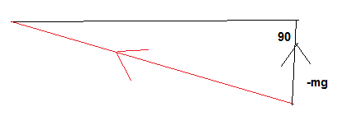
Must have component to support weight (1 mark)

  - A satellite that is constantly falling can maintain a circular path around the Earth at a constant altitude. Use a diagram help to explain why this occurs. (3 marks)
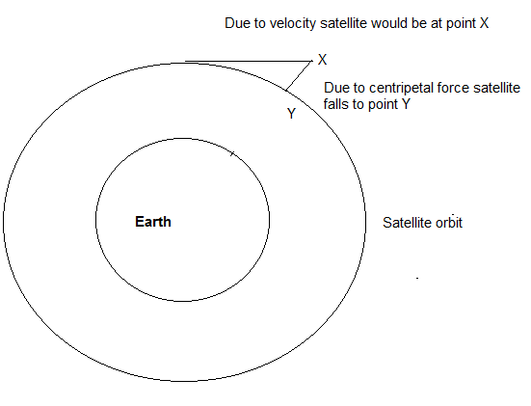 (1 mark)

But centripetal force is always at right angle to velocity (1 mark)

So this is continuous process, when in orbit always falls exact amount as it moves forward (Newton’s First Law) (1 mark)
Or similar

  - Explain why, that when a satellite is in a circular orbit around the Earth, the centre of its orbit must be the centre of mass of the Earth. Use diagrams. (2 marks)
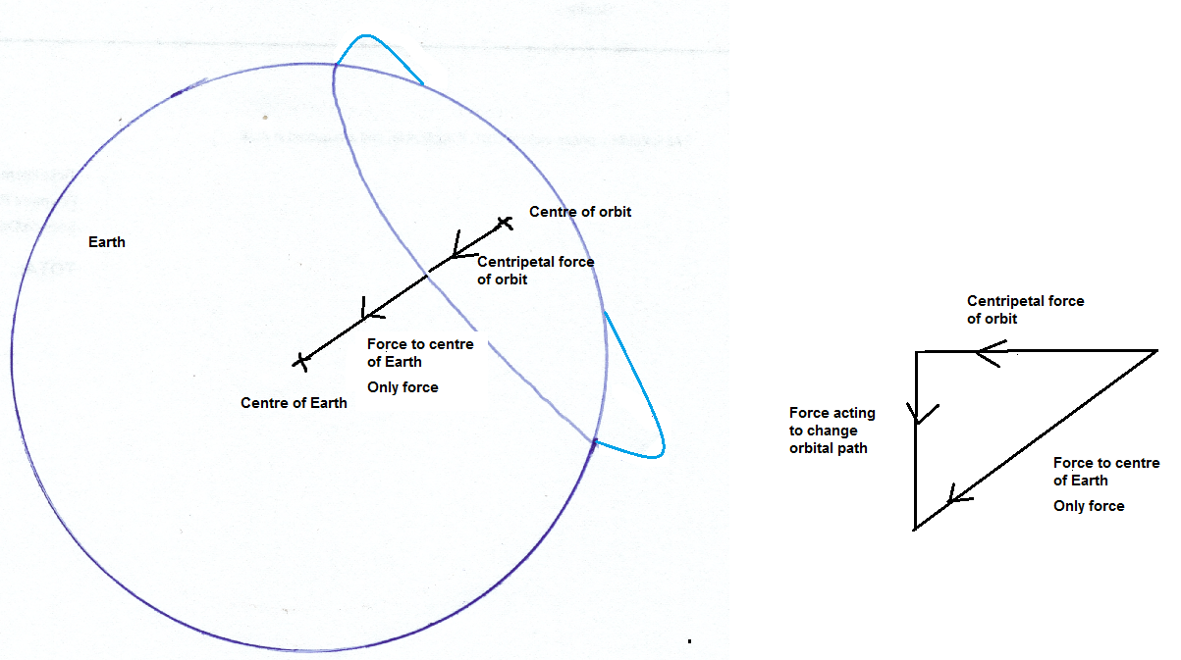
1 mark for each diagram

  - Whilst falling, the satellite could be said to be weightless. Explain. (3 marks)
The child’s perception of weight is due to the reaction force of the ground. (1 mark)
In free fall no reaction force. (1 mark).
Can only be weightless if infinite distance from ALL other masses. (1 mark)

Or similar

Question 19 AC/DC: Rock Band or Electricity Wars (18 marks)
Edison and Tesla, two great scientists found themselves on the opposite sides of the debate whether to use DC (Edison) or AC (Tesla).

Edison to prove his point that AC was too dangerous electrocuted an elephant and advocated that AC be used for the electric chair. Further he built 121 DC power stations in the United States of America. The Boulder power station in the Goldfields of Western Australia was originally a DC power station. Unfortunately, users of this power had to be within 2 km of the station. AC power could be readily converted from low to high voltages and back again so it could be transferred long distances with lower energy losses.

Much of our electronics today use DC power and when the AC is converted to DC about 3% energy is lost in the form of heat. Also LEDs which use DC suffer from flicker which reduces their lives, and solar panels produce DC current which is converted to AC using inverters. DC can now be converted to high voltages relatively easily and voltages for transmission of up to 800 kV have been achieved.

An issue with high voltage is the “skin effect” which means that at high voltages the current travels on the outside of the wire which effectively increases the resistance of the wire. This then requires that more expensive multi-strand wires are required to transmit the power. Further many places use UPSs (Uninterruptable Power Supplies) which convert AC to DC (batteries) then back to AC and then back to DC to run the electronics. Should we convert our power supplies to DC which is safer, much of our electronics use DC already and much of the green energy produced is DC and would be more compatible with a DC grid.

On the reverse many of our appliances are AC based and our power stations are all built to provide AC. Converting them would be a huge expense. The South/West power grid operated by Western Power extends from Kalbarri (600 km North of Perth) to Ravensthorpe (530 km SE of Perth) across to the coast, with an extension to Kalgoorlie.

Synergy is the electricity generator and retailer for the grid. They charge domestic customers 23.36630 cents per unit. A unit is a kilowatt hour.

A power station can generate 6.00 x 10² MW of energy at 30.0 kV. This is then sent to a sub-station where the voltage is increased to 3.30 x 10² kV. This is then transported at that voltage over large distances. It then comes to a series of sub-stations that step down the voltage to 33.0 kV, then 11.0 kV, 6.00 kV and finally about 4.00 x 10² V. Each transformer stage loses approximately 1.00% (ie 99% efficient).
The power is distributed from the last sub-station as three phase power down the streets. Most houses opt for one phase (~2.40 x 10² V) at a frequency of 50.0 Hz.

Large voltage wires are usually multi-strand aluminium cables surrounding an iron core which provides the tensile strength. The resistance of the wire is 1.02 x 10⁻⁴ Ω m⁻¹.

  - Explain why multi-strand wires are used in large voltage power lines. (2 marks)
High voltage electricity travels on outside of wire increasing resistance (1 mark)
Multi-strands provide more skin volume to carry current (1 mark)

b) Calculate the energy lost in transmitting 3.30 x 10² kV AC electricity from the generator to sub-station 1 to a town which is 151 km away. (7 marks)
Power loss in transformer = 1.00% x 600 MW
= 6.00 MW (1 mark)

P = VI
(600 – 6) x 10⁶ = 3.30 x 10⁵ x I
596 x 10⁶ = 3.30 x 10⁵ x I (1 mark)
I = 1.80 x 10³ A (1 mark)

P_{loss} = I²R
= (1.80 x 10³)² x 151 x 10³ x 1.02 x 10⁻⁴ W
(1 mark) (1 mark)
P_{loss in wires} = 49.9 MW (1 mark)
Total Power loss = 49.9 MW (1 mark)

Or similar

c) Calculate the loss over a year in possible revenue that Synergy loses because of this loss of energy? (4 marks)
1 year = 365.25 x 24 = 8.77 x 10³ hours (hr) (1 mark)
Energy loss = t x P = 8.77 x 10³ hr x 47.2 x 10³ kW (1 mark)
= 4.14 x 10⁸ kW hr (1 mark)
Cost = $4.14 x 10⁸ x 0.2336630
= $96.8 million (1 mark)

d) What is the voltage of three phase power in Western Australia? (1 mark)
400 V (1 mark)

e) Explain the cause of the “flicker” in LEDs. (3 marks)
LEDs need to run on DC (1 mark)
This results in 50 times every second there is no current (flickers) (1 mark)
as the LED (diode) only allows current in one direction (1 mark)
OR Any other suitable answer
(1 mark)

f) Why does DC lose less power in transmission than AC? (1 mark)
Resistance in wires is less. (1 mark)
Or similar
DC not affected by “skin effect”
AC is RMS affected whereas DC is not

End of Section 3
END OF EXAM
Additional working space

Additional working space

Additional working space

Additional working space

Additional graph if required.

End of examination

